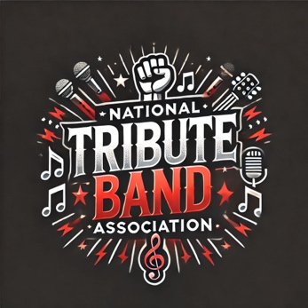

NTBA Tribute Band Rider agreement

(To accompany performance contract)
Provided by the National Tribute Band Association (NTBA)

Band Information
Band Name: ___________________________________________
Contact Name: _________________________________________
Phone Number: _________________________________________
Email: ________________________________________________
Date of Performance: ___________
Venue Name: __________________________________________
Venue Contact Name: ____________________________________

I. Technical Requirements
A. Stage
- Minimum stage size: ____ ft x ____ ft
- Clean, level surface with no obstructions or hazardous elements
- Minimum of 4 power outlets on stage (or power strips)
B. Sound (FOH)
The venue is responsible for providing a professional-quality PA system, appropriate for the size of the room and crowd. This should include:
- Mixing console with at least ____ channels
- 3 or more vocal microphones (Shure SM58 or equivalent)
- 3–4 instrument mics (guitar, kick, snare, etc.)
- Minimum 3 stage monitors, with individual mixes preferred
- DI boxes for bass, keys, tracks (if used)
- Cables, mic stands, and power as needed
- Professional sound engineer on-site
C. Lighting
- Basic stage wash lighting (LED or Par preferred)
- Spotlight or front lighting if available
- Optional: haze/fog, color washes, effects lighting
D. Backline (if provided by venue)
- Drum kit: 5-piece minimum with cymbals, throne, hardware
- Bass amp: [Preferred model or equivalent]
- Guitar amp(s): [Preferred model or equivalent]
- Keyboard stand and sustain pedal (if applicable)
Note: The Artist will provide guitars, bass, personal microphones, pedals, and in-ear monitor systems unless otherwise discussed.

II. Hospitality Requirements
A. Dressing Room
- Clean, private space for up to ___ performers
- Chairs, table, mirror, and hangers preferred
- Restroom access nearby
- Secure area to store personal items and equipment
B. Food & Beverage
For performances over 90 minutes or for full-day events:
- Minimum 1 meal per band member (buyout or vouchers acceptable)
- 12 bottled waters (room temp or cold)
- 6–12 beverages (choose: soda, sports drinks, non-alcoholic options)
- If alcohol is allowed and mutually agreed upon: [Optional] 1 case beer or well drink tickets
Note: Hospitality is negotiable based on show pay, distance traveled, and venue resources.

III. Load-In & Parking
- Reserved loading zone or back entrance required
- Parking for ___ vehicles, ideally near venue load-in
- Load-in access at least 2 hours before showtime
- Soundcheck: Minimum 30–45 minutes unless otherwise arranged

IV. Additional Notes
- Artist may request early arrival for setup and soundcheck
- Venue agrees to promote band via social media, website, and event listings
- Artist will tag and promote venue as part of agreed promotional activity
- Artist requests that name/logo is visible in all advertising and show materials

Agreement
By signing below, the venue agrees to make reasonable effort to meet the outlined technical and hospitality requests as part of the performance agreement.
Venue Representative:
Name: __________________________
Signature: _______________________
Date: ___________________________
Artist Representative:
Name: __________________________
Signature: _______________________
Date: ___________________________

Would you like this turned into a fillable PDF, Word doc, or stylized branded version for NTBA members? I can also customize it based on the number of band members or specific tribute acts (e.g., 80s synth pop vs. rock band).

